**SECTION A (46 Marks)**

***Answer all questions from this section A***

**1.** (a) Write:

(i) equation for ionization of methanoic acid in water. (1 ½ marks)

…………………………………………………………………………………………………………………………………………………………………………………………………………………………………………………………………………………………………………………………………………..

(ii) the expression for the acid constant Ka, for methanoic acid. (½ mark)

…………………………………………………………………………………………………………………………………………………………………………………………………………………………………………………………………………………………………………………………………………..

(b) The molar conductivity of 0.1M methanoic acid solution at 25oC is 16.2scm2 mol-1. Calculate the:

(i) Degree of ionisation of methanoic acid at 25oC (molar conductivity of methanoic acid at infinite dilution at 25oC is 40 scm2 mol-1) (1 ½ marks)

…………………………………………………………………………………………………………………………………………………………………………………………………………………………………………………………………………………………………………………………………………………………………………………………………………………………………………………………………………………………………………………………………………………………………………………………………………………………………………………………………………………………………………………………………………………………………………………………………………………………………………………………..

(ii) Ionization constant, Ka for methanoic acid at 25oC. (1 ½ marks)

……………………………………………………………………………………………………………………………………………………………………………………………………………………………………………………………………………………………………………………………………………………………………………………………………………………………………………………………………………………………………………………………………………………………………………………………………………………………………………………………………………………..

2. Write equations for the reaction of the following oxides with sodium hydroxide. (1 ½ marks each)

(a) Chromium (III) oxide.

…………………………………………………………………………………………………………………………………………………………

…………………………………………………………………………………………………………………………………………………………

(b) Beryllium oxide

…………………………………………………………………………………………………………………………………………………………………………………………………………………………………………………………………………………………………………………………………………..

(c) Lead (II) oxide

…………………………………………………………………………………………………………………………………………………………………………………………………………………………………………………………………………………………………………………………………………..

3. Complete the following reaction equations and write the accepted mechanism.

 (3marks)

………………………………………………………………………………………………………………………………………………………………………………………………………………………………………………………………………………………………………………………………………………………………………………………………………………………………………………………………………………………………………………………………………………………………………………………………………………………………………………………………………………………………………………………………………………………………………………………………………………………………………………………………………………………………………………………………………………………………………………………………………………………………

 (2marks)

……………………………………………………………………………………………………………………………………………………………………………………………………………………………………………………………………………………………………………………………………………………………………………………………………………………………………………………………………………………………………………………………………………………………………………………………………………………………………………………………………………………..

4. (a) State what is meant by the term **diagonal relationship?**. (1mark)

………………………………………………………………………………………………………………………………………………………………………………………………………………………………………………………………………………………………………………………………………………………………………………………………………………………………………………………………………………………………………………..

(b) State three reasons why lithium and magnesium resemble. (1 ½ marks)

…………………………………………………………………………………………………………………………………………………………

…………………………………………………………………………………………………………………………………………………………

…………………………………………………………………………………………………………………………………………………………………………………………………………………………………………………………………………………………………………………………………………..

(c) Mention three properties to show the diagonal relationship between lithium and magnesium. (3marks)

……………………………………………………………………………………………………………………………………………………………………………………………………………………………………………………………………………………………………………………………………………………………………………………………………………………………………………………………………………………………………………………………………………………………………………………………………………………………………………………………………………………..

5. 20cm3 of a gaseous hydrocarbon, X was exploded with 100cm3 of oxygen. After explosion, the volume and cooling of the residual gas was found to be 90cm3. On addition of concentrated potassium hydroxide, the volume reduced to 50cm3.

(a) Determine the molecular formula of X. (2marks)

……………………………………………………………………………………………………………………………………………………………………………………………………………………………………………………………………………………………………………………………………………………………………………………………………………………………………………………………………………………………………………………………………………………………………………………………………………………………………………………………………………………..

(b) X reacts with ammoniacal copper (I) chloride solution.

(i) State what is observed (1mark)

…………………………………………………………………………………………………………………………………………………………………………………………………………………………………………………………………………………………………………………………………………..

(ii) Write equation for the reaction that takes place. (1mark)

…………………………………………………………………………………………………………………………………………………………………………………………………………....................................................................................................................................

6. (a) Synthetic rubber (Z) was made from monomers with structure.



(i) State the conditions for the reaction. (1mark)

…………………………………………………………………………………………………………………………………………………………………………………………………………………………………………………………………………………………………………………………………………..

(ii) Write the equation leading the formation of Z (1mark) …………………………………………………………………………………………………………………………………………………………………………………………………………………………………………………………………………………………………………………………………………..

(iii) Name the type of reaction in a(ii) ( ½ mark)

……………………………………………………………………………………………………………………………………………………………………

(b) A solution containing 5.0g of Z in 200cm3 of benzene is found to have an osmotic pressure of 34KPa at 17oC. Calculate

(i) the molar mass of Z (2 ½ marks)

…………………………………………………………………………………………………………………………………………………………………………………………………………………………………………………………………………………………………………………………………………..

(ii) the number of monomers (n) (1 ½ marks)

…………………………………………………………………………………………………………………………………………………………………………………………………………………………………………………………………………………………………………………………………………..

……………………………………………………………………………………………………………………………………………………………………...……………………………………………………………………………………………………………………………………………………………………..

7. (a) State **Raoult’s law** of relative lowering of vapour pressure. (1marks)

…………………………………………………………………………………………………………………………………………………………………………………………………………………………………………………………………………………………………………………………………………..

(b)(i) Calculate the vapour pressure of a solution containing 18g of glucose (C6H12O6) in 50g of water at 60oC is 150mmHg. (2 ½ marks)

……………………………………………………………………………………………………………………………………………………………………………………………………………………………………………………………………………………………………………………………………………………………………………………………………………………………………………………………………………………………………………………………………………………………………………………………………………………………………………………………………………………..

(ii) State any three assumptions made in b(i) (1 ½ marks)

………………………………………………………………………………………………………………………………………………………………………………………………………………………………………………………………………………………………………………………………………………………………………………………………………………………………………………………………………………………………………………..

8. Sodium propanoate undergoes hydrolysis when dissolved in water.

a) Write equation for the hydrolysis of sodium propanoate (1mark)

…………………………………………………………………………………………………………………………………………………………………………………………………………………………………………………………………………………………………………………………………………..

b) Write the expression for the hydrogen constant, Kh (1mark)

………………………………………………………………………………………………………………………………………………………………………………………………………………………………………………………………………………………………………………………………………………………………………………………………………………………………………………………………………………………………………………..

c) The hydrolysis constant,Khfor sodium propaonate is 5.9 x 10-10 moldm-3 at 25oC. What is the concentration of hydrogen ions in solution at equilibrium for a 0.1M sodium propanoate? (2marks)

…………………………………………………………………………………………………………………………………………………………………………………………………………………………………………………………………………………………………………………………………………………………………………………………………………………………………………………………………………………………………………………………………………………………………………………………………………………………………………………………………………………………………………………………………………………………………………………………………………………………………………………………

9. (a) One of the properties of transition metals is complex ion formation

(i) Define the term **complex ion** (1mark)

…………………………………………………………………………………………………………………………………………………………………………………………………………………………………………………………………………………………………………………………………………..

(ii) Explain why transition metals form may complexes (1 ½ marks)

………………………………………………………………………………………………………………………………………………………………………………………………………………………………………………………………………………………………………………………………………………………………………………………………………………………………………………………………………………………………………………

(b) Complete the table below. (2marks)

|  |  |  |
| --- | --- | --- |
| Complex ion | Oxidation state of metal ion | Name of complex ion |
| (i) Fe(CN $)_{6}^{3-}$ |  |  |
| (ii) CuC $l_{4}^{2-}$ |  |  |

**SECTION B (54 MARKS)**

***Answer six questions from this section***

10. a) When red lead oxide, Pb3O4 was heated with dilute nitric acid, a solid was formed. Write equation for the reaction. (2marks)

………………………………………………………………………………………………………………………………………………………………………………………………………………………………………………………………………………………………………………………………………………………………………………………………………………………………………………………………………………………………………………..

(b)The mixture from (a) was filtered and the residue warmed with concentrated hydrochloric acid.

(i) State what was observed. (1mark)

………………………………………………………………………………………………………………………………………………………………………………………………………………………………………………………………………………………………………………………………………………………………………………………………………………………………………………………………………………………………………………..

(ii) Write equation for the reaction (1 ½ marks)

…………………………………………………………………………………………………………………………………………………………………………………………………………………………………………………………………………………………………………………………………………..

(c) The filtrate from (b) was divided into two portions.

(i) To the first portion was added aqueous potassium iodide. State what was observed and write equation for the reaction. (2marks)

………………………………………………………………………………………………………………………………………………………………………………………………………………………………………………………………………………………………………………………………………………………………………………………………………………………………………………………………………………………………………………..

(ii) The second portion evaporated to dryness and then heated strongly. State what was observed and write equation for the reaction. (2 ½ marks)

…………………………………………………………………………………………………………………………………………………………………………………………………………………………………………………………………………………………………………………………………………………………………………………………………………………………………………………………………………………………………………………………………………………………………………………………………………………………………………………………………………………………………………………………………………………………………………………………………………………………………………………………..

11. Name reagent(s) that can be used to distinguish between the following pairs of compounds and in each case state what is observed. (3marks)

a)

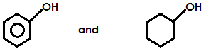

**Reagent**

…………………………………………………………………………………………………………………………………………………………………………………………………………………………………………………………………………………………………………………………………………

**Observations**

……………………………………………………………………………………………………………………………………………………………………………………………………………………………………………………………………………………………………………………………………………………………………………………………………………………………………………………………………………………………………………………………………………………………………………………………………………………………………………………………………………………..

(b) Ethanoic acid and chloroethanoic acid

**Reagent**

…………………………………………………………………………………………………………………………………………………………………………………………………………………………………………………………………………………………………………………………………………

**Observations.**

………………………………………………………………………………………………………………………………………………………………………………………………………………………………………………………………………………………………………………………………………………………………………………………………………………………………………………………………………………………………………………..

(c)

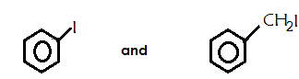

Reagent

…………………………………………………………………………………………………………………………………………………………………………………………………………………………………………………………………………………………………………………………………………

Observations

………………………………………………………………………………………………………………………………………………………………………………………………………………………………………………………………………………………………………………………………………………………………………………………………………………………………………………………………………………………………………………..

12. (a) State three properties in which manganese differs from magnesium. (1 ½ marks)

…………………………………………………………………………………………………………………………………………………………………………………………………………………………………………………………………………………………………………………………………………………………………………………………………………………………………………………………………………………………………………………………………………………………………………………………………………………………………………………………………………………………………………………………………………………………………………………………………………………………………………………………..

(b) Write equation to show the reduction of manganate (VII) ion in

(i) Acidic medium (1 ½ marks)

…………………………………………………………………………………………………………………………………………………………………………………………………………………………………………………………………………………………………………………………………………..

(ii) Alkaline medium (1 ½ marks)

…………………………………………………………………………………………………………………………………………………………………………………………………………………………………………………………………………………………………………………………………………..

(c) State what is observed when drops of acidified potassium manganate (VII) solution are added to each of the following solutions. In each case, write the equation of reaction.

(i) Hydrogen peroxide (2marks)

……………………………………………………………………………………………………………………………………………………………………………………………………………………………………………………………………………………………………………………………………………………………………………………………………………………………………………………………………………………………………………….

(ii) Hot sodium oxalate solution. (2marks)

…………………………………………………………………………………………………………………………………………………………………………………………………………………………………………………………………………………………………………………………………………..

(d) State one reason why potassium manganate (VII) is not a good primary standard in volumetric analysis (½ mark)

…………………………………………………………………………………………………………………………………………………………………………………………………………………………………………………………………………………………………………………………………………..

13. (a) State three characteristics of a **chemical equilibrium.** (1 ½ marks)

………………………………………………………………………………………………………………………………………………………………………………………………………………………………………………………………………………………………………………………………………………………………………………………………………………………………………………………………………………………………………………..

(b) Dinitrogentetraoxide dissociates at 40oC and 1 atm according to the following equation.

N2O4(g) 2NO2(g) H = +57 KJmol-1

(i) Write an expression for the equilibrium constant, Kp ( ½ mark)

…………………………………………………………………………………………………………………………………………………………………………………………………………………………………………………………………………………………………………………………………………..

(ii) Draw a labelled energy level diagram for the reaction in (b) (2marks)

…………………………………………………………………………………………………………………………………………………………………………………………………………………………………………………………………………………………………………………………………………………………………………………………………………………………………………………………………………………………………………………………………………………………………………………………………………………………………………………………………………………………………………………………………………………………………………………………………………………………………………………………..

(c) The reaction mixture in (b) was found to contain 60% by volume of nitrogen dioxide. Calculate the equilibrium constant Kp at 60oC for the reaction. (3marks)

……………………………………………………………………………………………………………………………………………………………………………………………………………………………………………………………………………………………………………………………………………………………………………………………………………………………………………………………………………………………………………………………………………………………………………………………………………………………………………………………………………………………………………………………………………………………………………………………………………………………………………………………………………………………………………………………………………………………………………………………………………………………………………………………………………………………………………………………………………………………………………………………………..

(e) Explain the effect of increasing pressure on the position of the above equilibrium. (2marks)

………………………………………………………………………………………………………………………………………………………………………………………………………………………………………………………………………………………………………………………………………………………………………………………………………………………………………………………………………………………………………………..

14. Write equations to show how the following compounds can be synthesized and in each case indicate the conditions of reaction.

(a) CH2 = CH2 from CH3CH2COOH (3marks)

…………………………………………………………………………………………………………………………………………………………………………………………………………………………………………………………………………………………………………………………………………………………………………………………………………………………………………………………………………………………………………………………………………………………………………………………………………………………………………………………………………………………………………………………………………………………………………………………………………………………………………………………..

(b) (3marks)

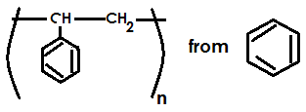

………………………………………………………………………………………………………………………………………………………………………………………………………………………………………………………………………………………………………………………………………………………………………………………………………………………………………………………………………………………………………………………………………………………………………………………………………………………………………………………………………………………………………………………………………………………………………………………………………………………………………………………………………………………………………………………………………………………………………………………………………………………………..

(c) (3marks)



………………………………………………………………………………………………………………………………………………………………………………………………………………………………………………………………………………………………………………………………………………………………………………………………………………………………………………………………………………………………………………………………………………………………………………………………………………………………………………………………………………………………………………………………………………………………………………………………………………………………………………………………………………………………………………………………………………………………………………………………………………………………..

15. The phase diagram for a mixture of metals **P** and **Q** is shown below.

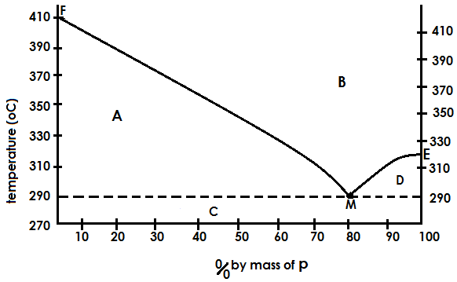

1. Identify the regions A, B, C and D (2marks)
2. A ……………………………………………………………………………………………………………………………
3. B ………………………………………………………………………………………………………………………………
4. C ………………………………………………………………………………………………………………………………
5. D ……………………………………………………………………………………………………………………………
6. State what point M represents. (1mark)

……………………………………………………………………………………………………………………………………………………………………………………………………………………………………………………………………………………………………………………………….

1. Using the diagram, estimate the melting point of; (1mark)
2. P …………………………………………………………………………………………………………………………………….
3. Q …………………………………………………………………………………………………………………………………..
4. Describe what would happen if a mixture containing 50% by mass of P and Q is cooled from 410oC to 270oC. (3marks)

…………………………………………………………………………………………………………………………………………………………………………………………………………………………………………………………………………………………………………………………………………………………………………………………………………………………………………………………………………………………………………………………………………………………………………………………………………………………………………………………………………………………………………………………………………………………………………………………………………………………………………………………..

1. State one difference and one similarity between the substance at point M and a pure compound
2. difference (1mark)

…………………………………………………………………………………………………………………………………………………………………………………………………………………………………………………………………………………………………………………………………………

1. similarity (1mark)

…………………………………………………………………………………………………………………………………………………………………………………………………………………………………………………………………………………………………………………………………………..

16. (a) Compound Y contains by mass 22.86% oxygen, 8.57% hydrogen and the rest carbon.

(i) Calculate the empirical formula of Y (2 ½ marks)

………………………………………………………………………………………………………………………………………………………………………………………………………………………………………………………………………………………………………………………………………………………………………………………………………………………………………………………………………………………………………………………………………………………………………………………………………………………………………………………………………………………………………………………………………………………………………………………………………………………………………………………………………………………………………………………………………………………………………………………………………………………………..

(ii) When 0.30g of Y is vapourised at 80oC and 700mmHg pressure, it occupied a volume of 134.77cm3. Determine the molecular formula of Y. (3 ½ marks)

……………………………………………………………………………………………………………………………………………………………………………………………………………………………………………………………………………………………………………………………………………………………………………………………………………………………………………………………………………………………………………………………………………………………………………………………………………………………………………………………………………………..

(b) Y forms a yellow precipitate with 2,4-dinitrophenyl hydrazine and does not react with Tollen’s reagent. Identify Y

Identify Y. (1mark)

…………………………………………………………………………………………………………………………………………………………………………………………………………………………………………………………………………………………………………………………………………..

(c) Write equation for the formation of the yellow precipitate in (b) above.(2marks)

……………………………………………………………………………………………………………………………………………………………………………………………………………………………………………………………………………………………………………………………………………………………………………………………………………………………………………………………………………………………………………………………………………………………………………………………………………………………………………………………………………………..

17. Explain the following observations

(a) phenylamine is a weaker base than ethyl amine (3marks)

…………………………………………………………………………………………………………………………………………………………………………………………………………………………………………………………………………………………………………………………………………………………………………………………………………………………………………………………………………………………………………………………………………………………………………………………………………………………………………………………………………………………………………………………………………………………………………………………………………………………………………………………..

(b) The PH of a 0.1M phenol is 6.5 while that of cyclohexanol is 7 (3marks)

…………………………………………………………………………………………………………………………………………………………………………………………………………………………………………………………………………………………………………………………………………………………………………………………………………………………………………………………………………………………………………………………………………………………………………………………………………………………………………………………………………………………………………………………………………………………………………………………………………………………………………………………..

(c) Hydrofluoric acid is a weaker acid than hydrobromic acid. (3marks)

………………………………………………………………………………………………………………………………………………………………………………………………………………………………………………………………………………………………………………………………………….

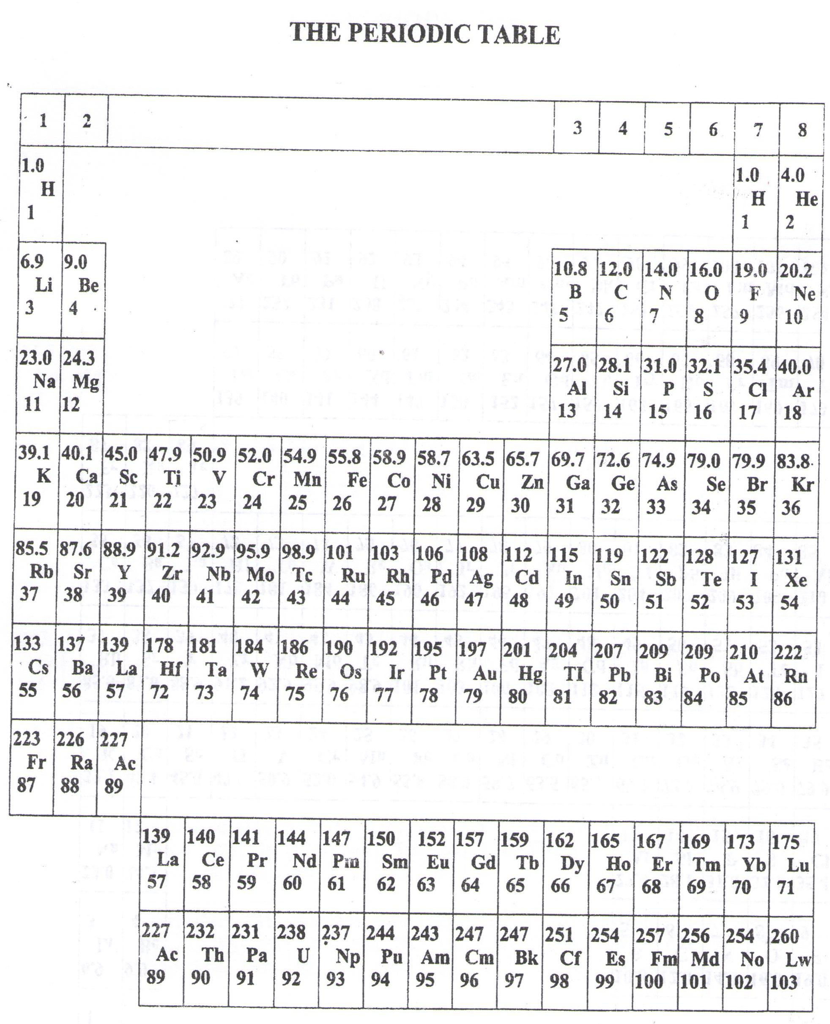

* ===END===

WELCOME TO SENIOR SIX, YEAR 2018

This is the last page of the printed paper, Page 14